**Light Microscopy Questions**

**1)** What is the function of the diaphragm?

**2)** Describe the advantage of having a microscope of highest resolution.

**3)** Calculate the magnification of the lens system of the following:  
      **a)** Ocular-10X Objective-10X  
      **b)** Ocular-10X Objective-43X  
      **c)** Ocular-10X Objective-1X  
      **d)** Ocular-10X Objective-2X  
  
**4)** What is the most important attribute of a microscope?

**Virtual Light Microscopy Questions**

1) How many individual cells can you count at the following objective powers of magnification?  
  
      a) 4X  
      b) 10X  
      c) 40X  
  
2) If the eyepiece has a 10X power, what is the total magnification when you observe cells at objective power of 40X?  
  
  
3) At what power are you able to discern the nucleus of the cheek cells? (The nucleus is the large, darker organelle located near the center of the cell)  
  
  
4) Describe what happens if there is too much illumination.

**Virtual Electron Microscope Questions**

**1)** How many bacteria do you think are on the image?  
  
**2)** Describe the different shapes of the bacteria that are visible.

**3)** Which cell is the largest between the macrophage and the bacteria?  
  
**4)** Describe the shape of the bacteria.  
  
  
**5)** Why do you think the virus has so many spikes on it?

**6)** Does the electron microscope allow a higher degree of magnification than the light microscope? Why?

**COMPOUND LIGHT MICROSCOPE QUIZ**Identify and list your answers below for each of the indicated parts of the compound light microscope

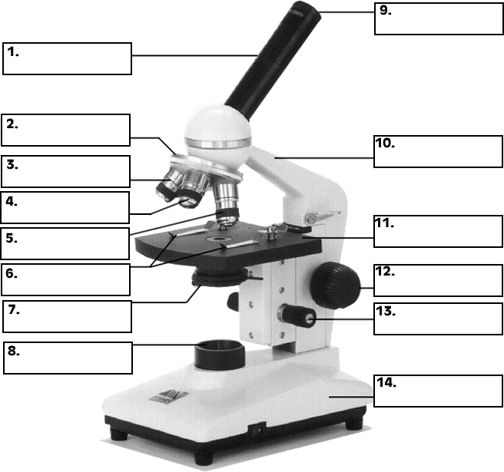

List Your Answers Here

|  |  |
| --- | --- |
| **1)** | **8)** |
| **2)** | **9)** |
| **3)** | **10)** |
| **4)** | **11)** |
| **5)** | **12)** |
| **6)** | **13)** |
| **7)** | **14)** |